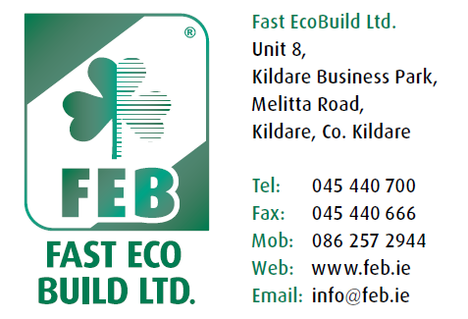

FAST Ecobuild LTD

FAST External Insulation System
Repair of System

- Using a disc cutter, cut through the FAST render 150mm beyond the area of damage/patch using a small or scraper chisel, remove the render from the reinforced adhesive coat.
- Cut out area of damaged insulation board, clean the substrate of any old adhesive.
- Cut a piece of insulation board to fit tightly into the damaged/patch area, sand the edges of the insulation board for a precise fit.
- Coat the entire back of the insulation board to a thickness of 2mm of adhesive. Do not apply adhesive on the edge of the insulation board.
- Install the insulation board on the substrate, make sure that the new insulation board is flush with the surrounding insulation board.
- Mask the surrounding area with masking tape and polythene, cut piece of reinforcing mesh so that it will cover the patch area, lapping on to the original reinforced adhesive coat a minimum of 100mm.
- Coat the area of patch with FAST adhesive and embed the reinforcing mesh in the adhesive, using a small damp brush smooth irregularities and feather the edge of the adhesive and allow to cure for a minimum of 48 hours.
- Apply a coat of FAST render to area of patch, thickness to suit existing render. Using a small damp brush, feather the edge of the render into existing render coat.

